Curriculum Vitae
Name: Lamiaa Mahmoud Ahmed Mohamed
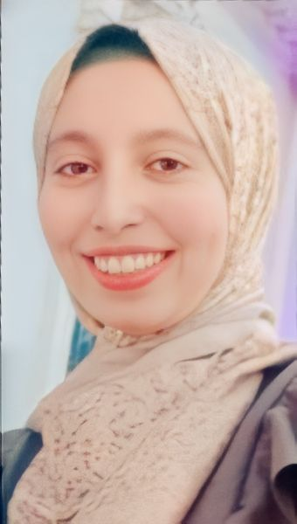
Date of Birth: May 11th , 1995
Gender: Female
Religion: Muslim
Nationality: Egyptian
Home Address: Sohag, Egypt
Contact Address: Department of Pharmaceutics, Faculty of Pharmacy, Assiut University.
E-mail: lamiaamahmoud21@yahoo.com
lamiamahmoud595@gmail.com
lamiamahmoud@pharm.aun.edu.eg

Languages:
English (professional), Arabic (nativelanguage).
Academic Qualifications:
Bachelor in Pharmacy, Faculty of Pharmacy, Assiut University, Assiut, Egypt, in 2018, and Demonstrator at Pharmaceutics Department, Faculty of Pharmacy, Assiut University
Excellence with honor (with score: 91.16%).
Grade:
Demonstrator at Pharmaceutics Department, Faculty of Pharmacy, Assiut University.

Computer Skills:
1- Microsoft Office Word.
2- PowerPoint

